Abstract
This project resembles a parking lot with a parking machine that takes several inputs from a user and recommends an unoccupied parking space for the user's vehicle.
The program will take input in the form of the vehicle's registration number, color and type of vehicle. A car occupies 1 place, a motorcycle takes 0,5 places and long vehicles, for instance a bus takes 2 places. The system will first check if there is a free parking place according to the vehicle category. Then the system will also show the price per hour/minute/second on the screen. At the same time, it will display a warning message that any unpaid extra time will be fined at a higher rate. The user can determine and manipulate the length of parking (ie, can decide how long to park, and extend the time if needed ). While parking, the system will show the total amount to be paid.
The program has 3 different stakeholders who use the program from 3 different perspectives. The Owner, The Parking Attendant and The Customer.
The Customer: people who will use the facility to park their car.
Area of interest: hassle-free parking experience.

The Parking Attendant: Partially responsible for optimal use of the place in terms of controlling if a car is parked outside the time of payment.
Area of interest: Financial gain by fining unpaid vehicles.

The Owner: Owns the program and the parking lot and is responsible for all the maintenance and upgrades of the parking lot.
Area of interest: Financial gain.

Personas
¤ Customer 1: Britt Marie is a 71-year-old woman and a pensioner. She usually parks her car for a very short time when she does her groceries. She wants to park her car as close to the entry of the shopping mall situated next to the parking lot. She can not walk long because of her age so getting a parking close to the entry will be helpful for her. She also wishes that there should be a discounted price for the pensioners.
¤ Customer 2: John is 38 years old bus driver. He usually parks his 36-sitter bus during the weekend. John is interested to know if he can get some discount as he parks his bus for a longer period of time. He is also interested in leasing possibilities on the weekends so he can have his dedicated parking place for the weekend so no other bus gets to park in his place.
¤ Customer 3: Sofia is a 36-year-old woman who works in a bank in the mall. She parks her electric-charged car every weekday from 8 AM to 5 PM. It is very important for her that she finds an unoccupied parking place on weekdays, otherwise, she might be late for her work. Besides, she also wishes for a parking place with an electric charging facility so she can charge her car at the same time. She has already discussed the issue with her employer and the employer has shown interest in hiring a parking spot with a car charging facility but not as a private customer, but instead as a business(B2B customer).
¤ Customer 4: Timothy is a 53-year-old man. He is partially handicapped and a handicap license holder. He wishes to park his car at a dedicated handicap parking spot that should be just by or in front of the entry to the mall. And he also wishes that the parking lot has a discounted price for the handicaps.
¤ Customer 5: Helen is a 22-year-old woman who drives a motorcycle. She does not have any specific requirements. She thinks that sometimes other MC drivers park their MCs too close to another MC and the place can be very narrow. She wishes that MC parking places would be a bit larger (will be 1,5 parking places DVS 2 MC will share 1,5 parking places instead of 1).
¤ Parking Attendant: Magnus is 62 a 62-year-old man working as a parking attendant for the last 34 years. He is a man with a lot of experience and knows all the excuses and tricks people use to escape a parking penalty. He is very strict and dedicated to his job and never misses an opportunity to place a ticket on the windshield of a vehicle. He wishes to see a list of the parking lot and also which spots are occupied and time left to check out on the screen in his car system.
¤ Owner: Bjorn has been working as a manager for the last 20 years for different organizations. He is now 46 and possesses extraordinary analytical abilities and interpretation of numbers and different situations and always looking for an opportunity to generate extra revenue for his organization. He has been working as the parking lot manager for the last 2 years and already pointed out that he needs to have more statistics to increase revenue. He needs to know if he can increase or decrease the number of parking places for different types of vehicles according to usage, if more charging stations are needed, does the lot need more handicap parking. If leasing parking to businesses or applying long-term parking options, special weekdays or weekend packages are viable and feasible for his organization. And of course how much revenue the parking lot generates daily.

User stories

This program is aimed at 3 different categories of users.
- As a customer/user of a parking lot the user needs to receive suggestions for parking his/her vehicle at a specific parking number and at the same time see the cost of parking. The customer needs to add the time span that he/she wishes to park the vehicle and also can check out before parking time ends.
- As a parking assistant, the user needs to see the overall status of the parking lot, which parking number is free and which one is occupied. The assistant also needs to see which registration number is parked in which parking number and what is the time situation(ie, how much time left to finish parking, if the parking time has already passed). Lastly, the assistant needs the possibility to fine the customer according to how much extra time the vehicle has been parked.
- As the administrator/owner of the system, the user needs to see the overall scenario of the parking lot and receive the information that how much revenue the parking lot generates.
The planning phase
As a group, we all sat together and discussed every possible way of solving the problem and the obstacles we have. After a thorough examination of the user stories, we created a flow chart and broke down the problem into 3 different parts.
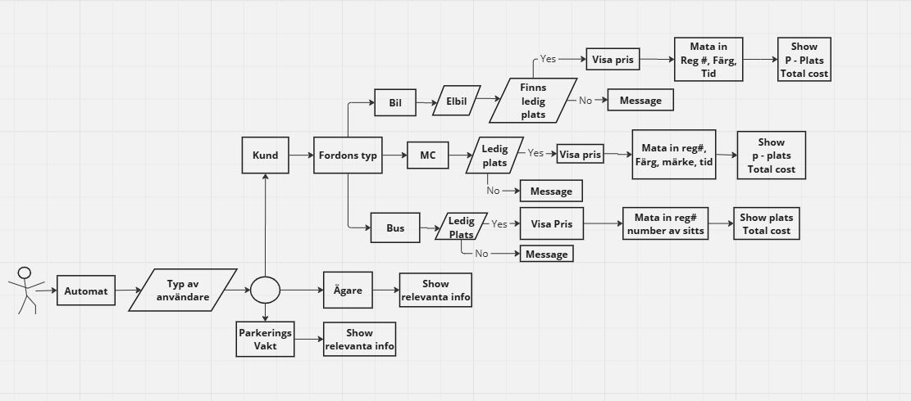 We planned to design the program according to the flowchart. When the user starts using the program he/she will be greeted with a welcome message and can identify him/herself as the user category, ie, customer, parking assistant or an administrator. We have also discussed about Agile Development and included the possibilities for adding more features in the future. We also decided to contact each other and have SCRUM meetings twice a week or whenever needed.
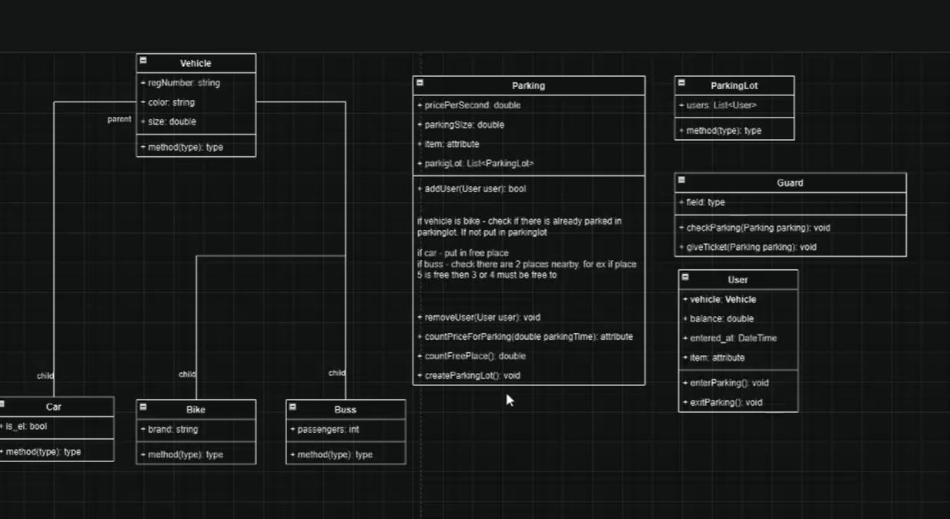
On our first SCRUM, we discussed the next phase of developing the program and decided on what are the variables, users, classes, sub-classes and methods we need.
On the second SCRUM we decided what to show on the first Sprint. We started with the vehicle class and completed the Car, Bus and Mc sub class. We also focused on completing the methods that need to create objects from a class. We started with our kanban (https://trello.com/b/JQBcLQLq/pionuskyh) and agreed on using and updating that regularly.

Reflection on the first Sprint
Problems :
Although we successfully completed the first sprint, we experienced many obstacles as a team in the Agile Development process.
- We did not have regular SCRUM meetings. We decided to meet or contact on Discord only when we felt the need.
- As a team, we did not have a clear vision. As a result several group members worked with the same task.
- There had always been communication and a gap in the level of competence that led our project to progress at a slow pace.

Learnings:
- We need to organize SCRUM meetings regularly. Preferably every day.
- Need clear direction and explanation from those who are experienced in programming. How the program development should progress, who does which part, etc.
- Every member should take his/her responsibility for working on his/her part and also submit those on time.
- We need to try par programming and mob programming.
- We need to be prepared for any sudden changes and adapt and accept different approaches to solving problems if our solution does not perform as we expected it to.

Progress:
- We have made significant progress in communication. During the last week, we held a higher number of SCRUM meetings.
- We approached mob programming.
- We have had better planning for Sprint review for the following week where the team members could discuss what we will demonstrate and who will present our progress.
- We started using kanban in a prolific way as the teams mode of communication and also showing the development of the program.

